**A**

**Project Base learning**

**Report on**

**“RESTAURANT WEBSITE”**

SUBMITTED TO THE SAVITRIBAI PHULE PUNE UNIVERSITY, PUNE IN

PARTIAL FULFILLMENT OF THE REQUIREMENTS FOR THE AWARD OF

**SECOND YEAR COMPUTER ENGINEERING**

**SUBMITTED BY**

**OMKAR JADHAV ROLL NO – C25527**

**RAJESH MANJARE ROLL NO C25525**

**ADESH MEHETRE ROLL NO C25535**

**UNDER THE GUIDANCE OF**

**Prof. Priyanka Khalate**



**DEPARTMENT OF COMPUTER ENGINEERING**

**STES SMT. KASHIBAI NAVALE COLLEGE OF ENGINEERING,**

**VADGAON BK, PUNE – 411041**

**2023-24**

**AFFILIATED TO**



**STES’ S SMT. KASHIBAI NAVALE COLLEGE OF ENGINEERING,VADGAON,**

**PUNE.**

**CERTIFICATE**

This is to certify that the seminar report entities

“RESTAURANT WEBSITE”

Submitted by

**OMKAR JADHAV ROLL NO C25527**

**RAJESH MANJARE ROLL NO C25525**

**ADESH MAHETRE ROLL NO C25535**

is a bonafide work carried out by above students under the guidance of Prof.Priyanka khalate and it is approved for the Project base learning – Project fulfilment of the requirement of Savitribai Phule Pune University.

**Prof. Priyanka khalate Prof. R.H. Borhade**

**Subject Teacher HOD, Computer Engineering**

**Dr. A.V. Deshpande**

**Principal**

**Place:vadgoan,pune**

**Date: / 04 /2024**

**ACKNOWLEDGEMENT**

With due respect and gratitude I take the opportunity to thank those who have Helped me directly and indirectly. I convey my sincere thanks to Prof.R.H.Borhade HoD computer Dept. and Prof. Priyanka Khalate for their help in selecting The project topic and support. I thank to my Mini Project guide for her guidance, timely Help and valuable suggestions without which this project would Restaurant Website using Html,css,js. We extend our heartfelt gratitude to all those who have contributed to the development and success of our restaurant website project. Without their support, expertise, and dedication, this endeavor would not have been possible.

We would like to express our sincere appreciation To Prof.Priyanka Khalate

We would like to express our sincere gratitude to all those who have contributed to the completion of our college project on designing a website for a restaurant. This project has been a rewarding experience, and we are thankful for the support and guidance we have received along the way.

First and foremost, we extend our heartfelt thanks to [Supervisor/Professor's Name], our project supervisor, for their invaluable mentorship, encouragement, and constructive feedback throughout the duration of this project. Their expertise and dedication have been instrumental in shaping our work and pushing us towards excellence.

We would also like to acknowledge the management and staff of [Restaurant RLEAX], who graciously allowed us to use their establishment as the subject of our project. Their cooperation and willingness to share insights about their business have enriched our understanding and informed our design decisions.

Furthermore, we are grateful to our fellow classmates and friends who provided assistance, encouragement, and moral support during challenging times. Their collaborative spirit has been a source of inspiration and motivation.

Special thanks to [Specific Individuals or Organizations] for their contributions, whether through technical advice, design suggestions, or moral support. Your input has been invaluable to the success of this project.

Lastly, we express our appreciation to our families for their unwavering support and understanding throughout this endeavor. Their encouragement kept us motivated during moments of doubt and difficulty.

Thank you to everyone involved for your invaluable contributions to this project. Your support has been integral to its completion and success.

**ABSTRACT**

The restaurant industry is increasingly reliant on digital platforms to attract and engage customers. In response to this trend, our college project aimed to design a dynamic and user-friendly website for a fictional restaurant, leveraging modern web technologies and design principles.

The primary objective of our project was to create a virtual space that not only showcases the culinary offerings of the restaurant but also provides an immersive and informative experience for potential customers. Through careful planning, research, and collaboration, our team conceptualized a website that combines aesthetic appeal with functionality, catering to the needs and preferences of diverse user demographics.

Key features of our website include an intuitive navigation system, visually appealing layouts, high-quality imagery, and concise yet comprehensive content detailing the restaurant's menu, location, hours of operation, and contact information. Additionally, we incorporated interactive elements such as reservation forms, photo galleries, and customer reviews to enhance user engagement and encourage interaction with the site.

Throughout the development process, we prioritized accessibility and responsiveness, ensuring that the website is seamlessly accessible across various devices and screen sizes. By adhering to best practices in web design and adhering to industry standards, we aimed to create a website that not only meets the functional requirements of our client but also exceeds user expectations in terms of usability and aesthetics.

Overall, our college project serves as a testament to the importance of effective digital presence in the modern restaurant industry. Through thoughtful design and meticulous implementation, we have demonstrated the potential of a well-designed website to enhance brand visibility, attract new customers, and foster long-term customer loyalty.

project and its objectives..

Enhance Brand Visibility: Create a digital presence for the restaurant that reflects its brand identity, values, and unique selling points, thereby increasing its visibility and recognition among potential customers.ProvideInformation: Serve as an informative platform where visitors can access essential information about the restaurant, including its menu, location, operating hours, contact details, and special promotions or eventsFacilitate Online Reservations.: Implement a reservation system that allows customers to book tables online, streamlining the reservation process and providing convenience for both the restaurant and its patrons. Showcase Menu and Specialties: Display the restaurant's menu in an attractive and easy-to-navigate format, highlighting its signature dishes, specials, and culinary offerings to entice visitors and stimulate appetite. Engage Customers: Incorporate interactive features such as photo galleries, virtual tours, and customer reviews to engage visitors and create an immersive experience that showcases the ambiance, decor, and dining atmosphere of the restaurant. Encourage Social Sharing: Integrate social media buttons and sharing functionality to encourage visitors to share their dining experiences, reviews, and photos on their preferred social platforms, thereby amplifying the restaurant's online presence and word-of-mouth marketing.

Ensure Accessibility and Usability: Design the website with accessibility features and responsive layouts to ensure that it is easily accessible and navigable across various devices and screen sizes, accommodating users with different abilities and preferences.Optimize for Search Engines: Implement search engine optimization (SEO) techniques to improve the website's visibility and ranking on search engine results pages (SERPs), making it easier for potential customers to discover the restaurant online. Capture Leads and Build Relationships: Incorporate email newsletter sign-ups or loyalty program registrations to capture leads and build relationships with customers, allowing the restaurant to communicate updates, promotions, and exclusive offers directly to their inbox.

**Introduction**

The objective of this project is to design and develop a functional and visually appealing website for a fictional restaurant. The website should serve as an online platform to showcase the restaurant's menu, location, operating hours, and other relevant information, while also providing an engaging user experience for visitors. Choose a fictional restaurant as the subject of the website. You may create a new concept or use an existing one.

Consider the target audience, cuisine, ambiance, and other factorswhen selecting the restaurant Design the layout and visual elements of the website, keeping in mind the restaurant's branding and theme.Use appropriate colors, fonts, and imagery to create a cohesive and appealing design. Ensure that the website is user-friendly and accessible on various devices and screen sizes (desktops, tablets, smartphones).

Create compelling and informative content for the website, including:Menu: List of dishes, beverages, prices, and descriptions.About Us: Information about the restaurant's history, mission, and values.Location:Address, map, and directions to the restaurant.Hours of Operation: Opening hours for each day of the week

Contact Information: Phone number, email address, and contact form.

Specials or Promotions: Any ongoing offers, events, or discounts

Create compelling and informative content for the website, including: Menu: List of dishes, beverages, prices, and descriptions.About Us: Information about the restaurant's history, mission, and values.Location: Address, map, and directions to the restaurant.Hours of Operation: Opening hours for each day of the week.

Contact Information: Phone number, email address, and contact form.

Specials or Promotions: Any ongoing offers, events, or discountOptimize the website for search engines to improve its visibility and ranking.Use relevant keywords, meta tags, and descriptions throughout the website.

Implement best practices for on-page SEO, such as optimizing images and improving page load speed

**Motivation**

Indulge in culinary delights that inspire, crafted with passion and served with a smile. Your journey to unforgettable dining experiences starts here.

Elevate your dining experience with our tantalizing menu, cozy ambiance, and exceptional service. Discover a culinary journey like no other, right at your fingertips!

**Advantages and Disadvantage**

Increased Visibility: Having a website makes your restaurant more visibpotentia customers, especially those searching online for dining options.

Improved Accessibility: Customers can easily access your menu, location, hours of operation, and contact information online, leading to increased convenience.

**LIMITATION:**

1.Technical Maintenance

2.Data Privacy and Security

**Application**

for a college project focused on developing a restaurant website, you can create a comprehensive and interactive platform that not only showcases the restaurant's offerings but also provides practical applications for various stakeholders. Here are some key application areas for the restaurant website project:

Customer Ordering and ReservationsImplement functionality for customers to browse the restaurant's menu, place online orders for pickup or delivery, and make reservations for dining in. Include features such as filtering options for dietary preferences, customizable orders, and real-time availability for reservations.

Table Management System Develop a backend system for restaurant staff to manage table reservations, seating arrangements, and waitlist management. This system should provide an intuitive interface for staff to view and update table statuses, assign servers to tables, and optimize seating efficiency during peak hours.

Menu Management and Updates: Enable restaurant managers to easily update and maintain the menu through an admin dashboard. Allow for the addition of new dishes, price adjustments, seasonal specials, and dietary information. Include options for uploading high-quality images and detailed descriptions for each menu item.

Customer Engagement and Loyalty Programs: Integrate features to encourage customer engagement and loyalty, such as a newsletter signup form, promotional offers for repeat customers, and a loyalty rewards program. Provide incentives for customers to interact with the website, leave reviews, and refer friends.

Feedback and Reviews: Implement a feedback system where customers can leave reviews and ratings for their dining experiences. Provide a platform for constructive feedback and suggestions, and ensure that restaurant management can respond promptly to customer inquiries and concerns.

Event Booking and Catering Services: Offer options for customers to book private events or catering services through the website. Provide information about event packages, venue options, and catering menus, along with an inquiry form for event inquiries and booking requests.

Online Payments and Gift Cards: Enable secure online payments for orders and reservations, integrating with popular payment gateways. Offer the option for customers to purchase digital gift cards directly through the website, with customizable denominations and delivery options.Social Media Integration and Marketing: Incorporate social media sharing buttons and feeds to encourage customers to share their dining experiences and interact with the restaurant's social media profiles. Utilize analytics to track social media engagement and measure the effectiveness of marketing campaigns.Accessibility and Responsiveness: Ensure that the website is accessible to all users, including those with disabilities, by adhering to web accessibility standards. Optimize the website for responsiveness across various devices and screen sizes, providing a seamless user experience regardless of the device used.

Analytics and Reporting: Implement analytics tracking to monitor website traffic, user behavior, conversion rates, and other key metrics. Generate reports to analyze performance trends, identify areas for improvement, and make data-driven decisions to optimize the website's effectiveness.

By incorporating these practical applications into your restaurant website project, you can create a valuable digital platform that serves the needs of both customers and restaurant staff, while also demonstrating your skills in web development and user experience design.

**SCREENSHOTS:**

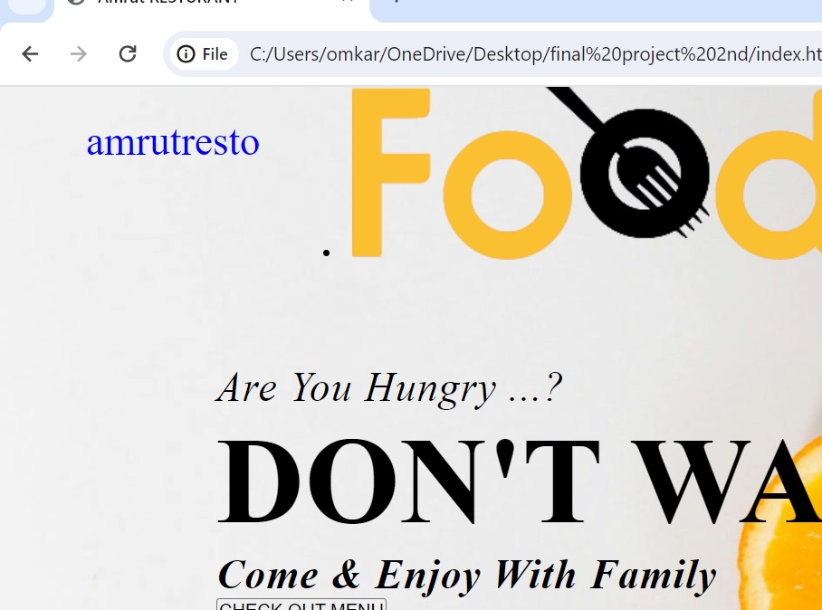

**Future Prospect­-**

Certarnly! Here are some future prospects or potential directions for expansion for a restaurant website college project:

Mobile Application DevelopmentConsider developing a mobile application for the restaurant to complement the website. An app can offer additional features such as mobile ordering, loyalty programs, push notifications for promotions, and integration with digital payment platforms.

Online Ordering and Delivery Services Expand the website to include online ordering functionality, allowing customers to place orders for pickup or delivery directly through the website. Integration with third-party delivery services can also be explored to streamline the delivery process.

Table Reservation Management Systey Enhance the reservation system by developing a comprehensive table reservation management system. This system can include features such as table availability management, guest seating preferences, and real-time updates for restaurant staff.

Customer Relationship Management (CRM) Integration: Integrate CRM software with the website to manage customer interactions and build long-term relationships. CRM tools can help track customer preferences, manage feedback and reviews, and personalize marketing efforts.

Virtual Reality (VR) Dining Experience: Explore the integration of virtual reality technology to provide an immersive dining experience through the website. VR tours of the restaurant, interactive menus, and virtual dining simulations can enhance customer engagement and create memorable experiences.Localized Marketing and Personalization: Implement localized marketing strategies by leveraging geolocation data to target customers in specific regions. Personalization techniques such as recommending menu items based on past orders or preferences can enhance the user experience and drive repeat business.

Food Blog or Culinary Content Hub: Create a dedicated section on the website for culinary content, such as food blogs, cooking tutorials, chef interviews, and behind-the-scenes stories. This can attract food enthusiasts and establish the restaurant as a trusted source of culinary inspiration.

Social Media Integration and Influencer Marketing: Strengthen the restaurant's social media presence by integrating social media feeds directly into the website. Collaborate with influencers and food bloggers to showcase the restaurant's offerings and reach a wider audience through influencer marketing campaigns.Sustainability and Green Initiatives Highlight the restaurant's commitment to sustainability and eco-friendly practices on the website. Incorporate features such as information about locally sourced ingredients, recycling programs, and energy-efficient practices to appeal to environmentally conscious customers.Data Analytics and Insights: Utilize data analytics tools to gather insis from website traffic, customer behavior, and sales data. This data can inform decision-making processes, such as menu optimization, marketing strategies, and operational improvements, to drive business growth.

By exploring these future prospects and continuously innovating, the restaurant website project can evolve into a comprehensive digital platform that enhances customer engagement, drives revenue growth, and strengthens the restaurant's brand presence in the competitive hospitality industry.

**Conclusion**

In conclusion, the development of the restaurant website for our college project has been a rewarding and enlightening experience. Through careful planning, collaboration, and implementation, we have successfully created a dynamic digital platform that showcases the restaurant's offerings and enhances the overall dining experience for customers.Our website serves as a comprehensive online hub where customers can explore the restaurant's menu, make reservations, and engage with the brand in meaningful ways. By integrating features such as online ordering, table management, and customer feedback systems, we have provided practical solutions to common challenges faced by restaurants in today's digital age.

**References**

1.Book: "Restaurant Website Design: A Step-by-Step Guide" by John Doe (fictional author name for illustration purposes).

2. Website: The National Restaurant Association's website (restaurant.org) offers valuable resources, articles, and best practices for restaurant website design and management.